**Guidelines for National Experts (update February 2021)**

**How to report the evaluations identified in the new online Database**

|  |
| --- |
| **Link** to access the online Helpdesk Database (DB):  <https://evhelpdesk3.azurewebsites.net/>  **Login** using the credentials sent via email.  To log in – From the Home page click on View Evaluation (top bar) and the Login window will appear |

You can visualise the following pages:

1. **View Evaluations – Evaluations**

List of all evaluations included so far in the Database

1. **Update evaluation – Add new evaluations**

List of evaluations related to your country which you have included but not yet submitted for review.

1. **Code tables**

List of abbreviations used in the template grouped by:

* Countries, Language, Funds, TOs/IPs
* OPs and CCI codes
* Evaluation characteristics

1. **Help**

* Contacts of the Helpdesk team
* Resources which include the Guidelines for national Experts

1. **View evaluations**

Click on View Evaluations in the toolbar and select Evaluations

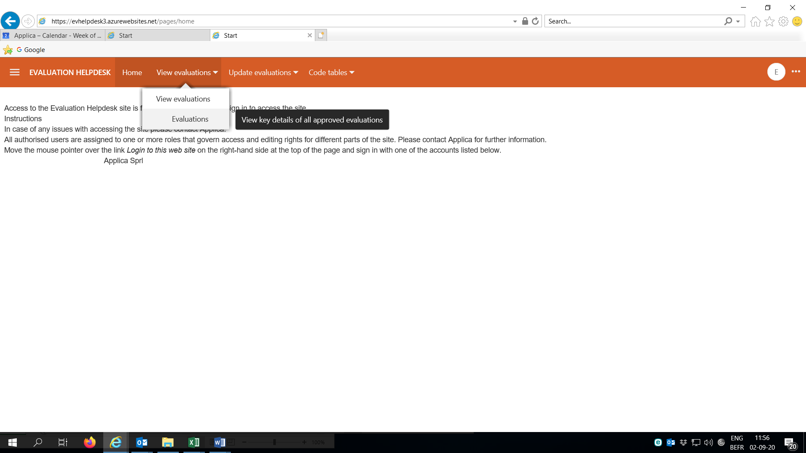

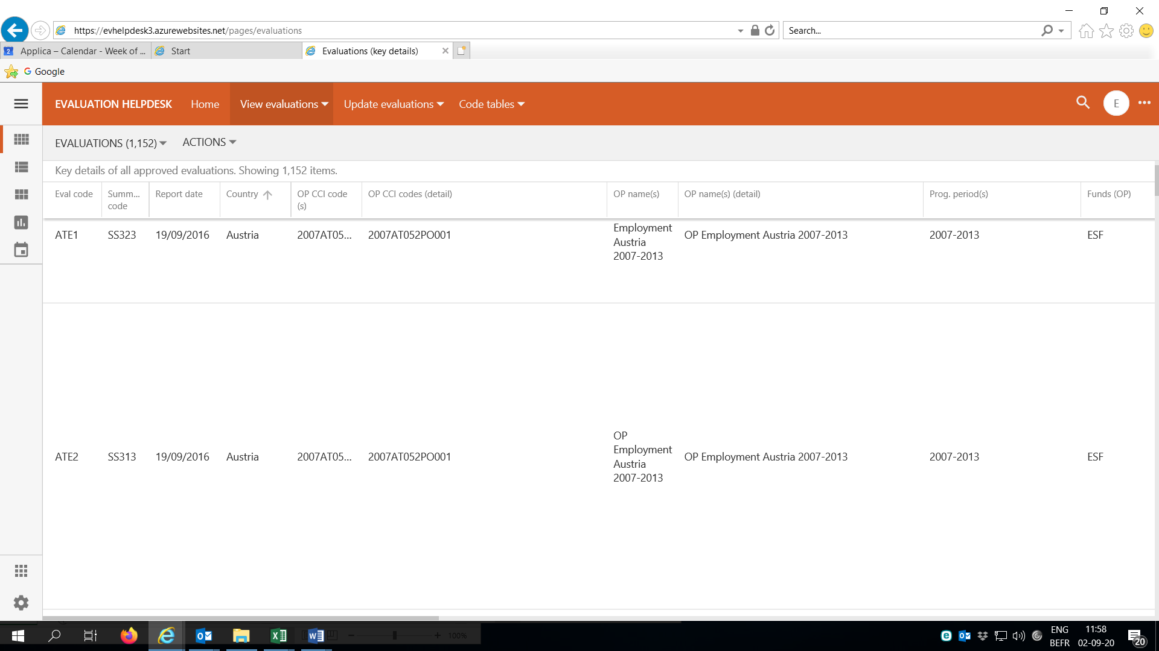

When you click on a specific evaluation, details appear on the left of the screen.

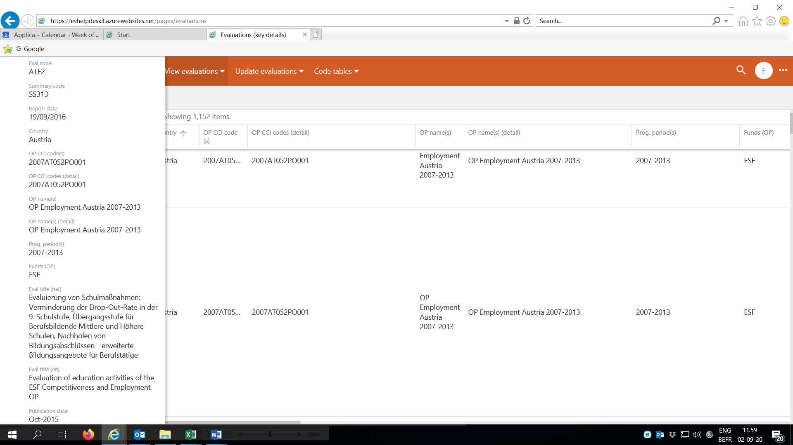

|  |
| --- |
| Note:  The variables **OP CCI code(s) detail** and **OP Name(s) detail** list all OP(s) which are the subject of the evaluation concerned.  The variables **OP CCI code(s)** and **OP Name(s)** are created *ad hoc* by the Helpdesk to group OP Names and CCI codes in those cases where the evaluation covers a large number (or all) OPs of a MS. |

Evaluations can be ordered, grouped and filtered by any variable. When you click on a variable, a window appears where you can select what to do.

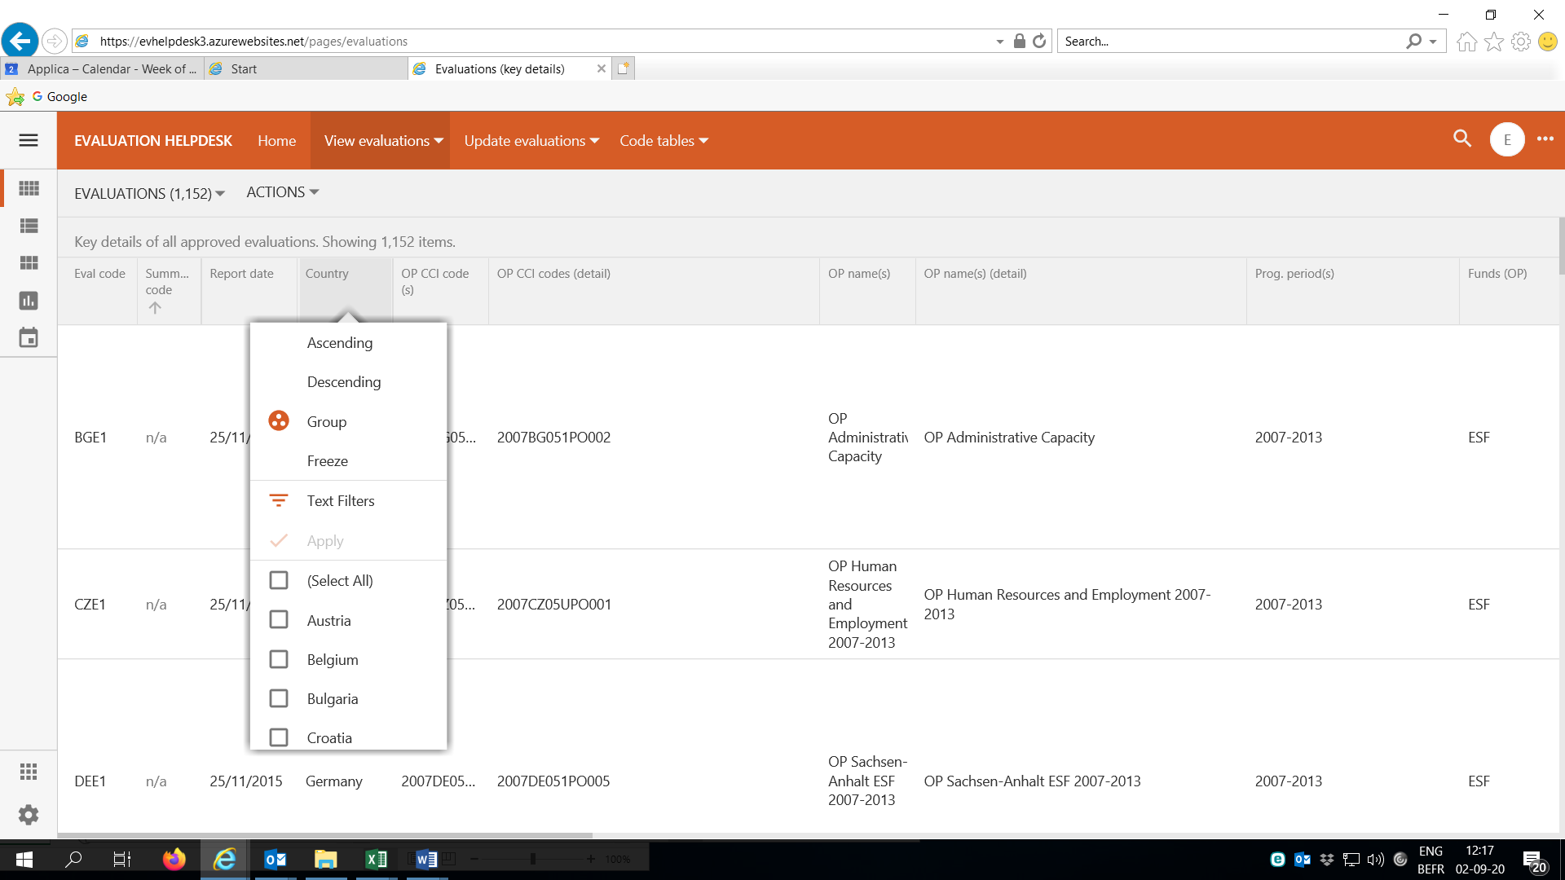

The information can be downloaded by clicking on **Actions**.

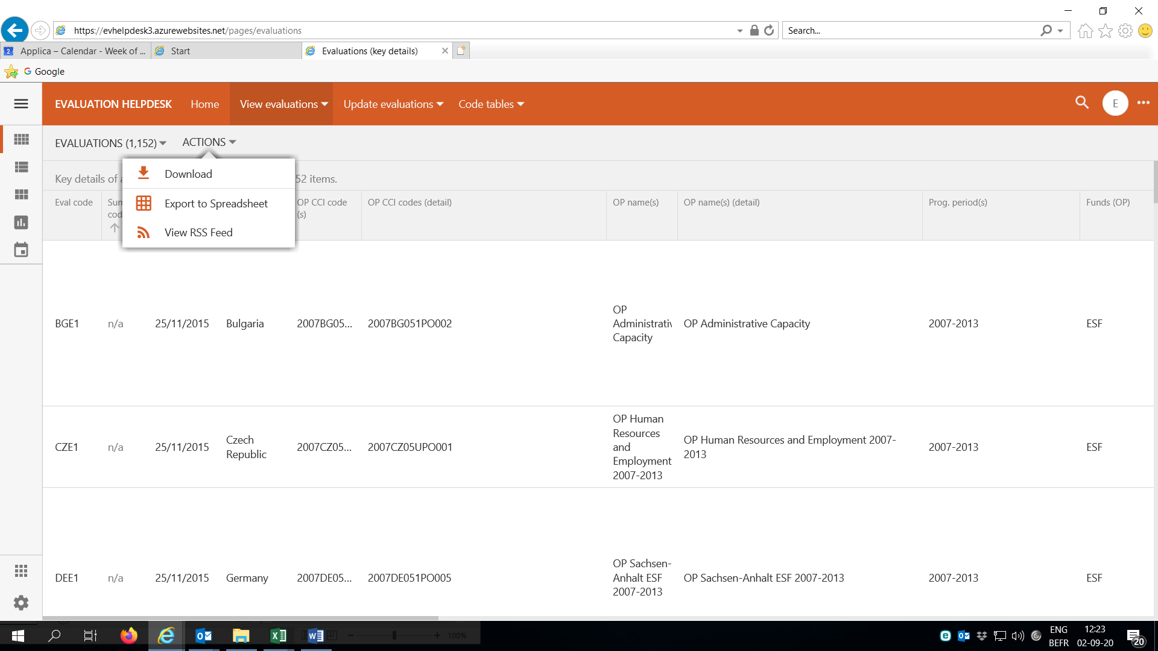

1. **Update evaluation – Add new evaluations**

**Add new evaluations**

|  |
| --- |
| **Important**: Before including a new evaluation please check in the List of Evaluations that the evaluation is not already included in the Database |

Click on the **Plus** sign on the bottom right of the page to add a new evaluation. A pop-up window will appear as below:

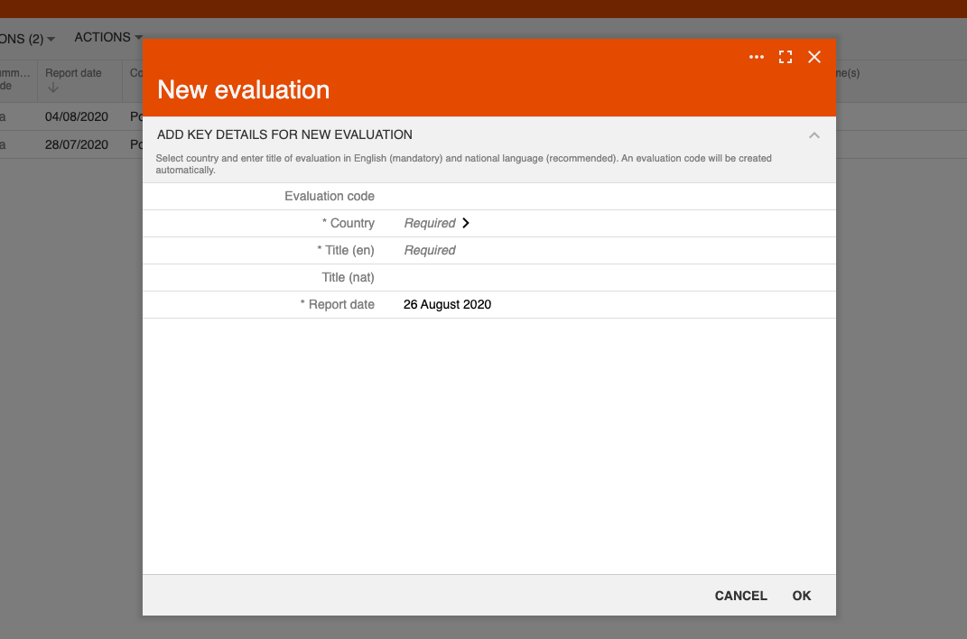

Select the **Country** and the evaluation code will be created automatically.

Enter the remaining information, i.e. Title in English and in the original language and the reporting date. Then click **ok**.

The pop-up window is closed and the evaluation is automatically added to the list of new evaluations created but not yet submitted for review.

To complete the template with the remaining information related to the evaluation just created, click on the relevant evaluation. A Review / Edit pop-up window opens (see below) where the following options are available: **Edit** to complete the template with the missing information, **Delete** to remove the evaluation from the list or **Close** to close the pop-up window.

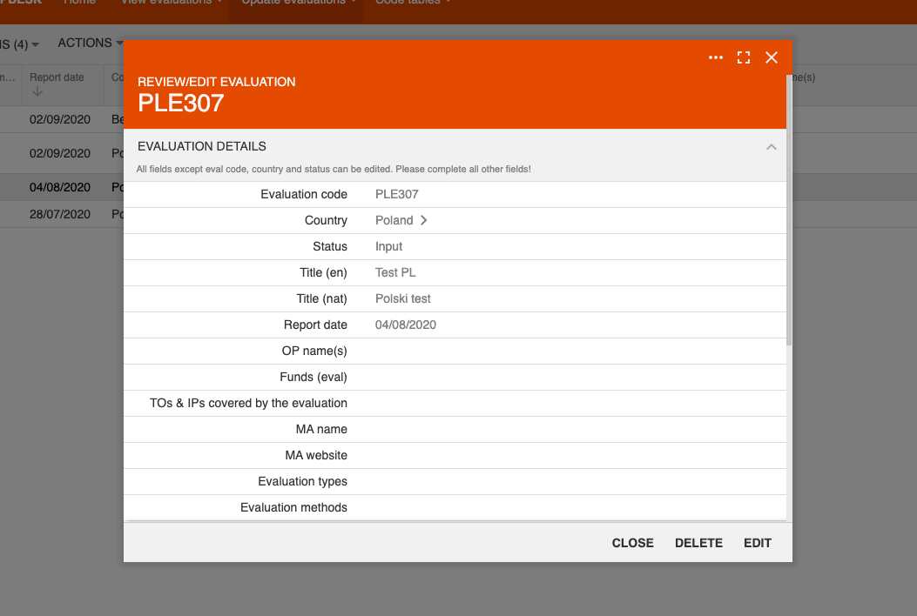

To complete the evaluation template click **Edit** and a pop-up window with the full template will open:

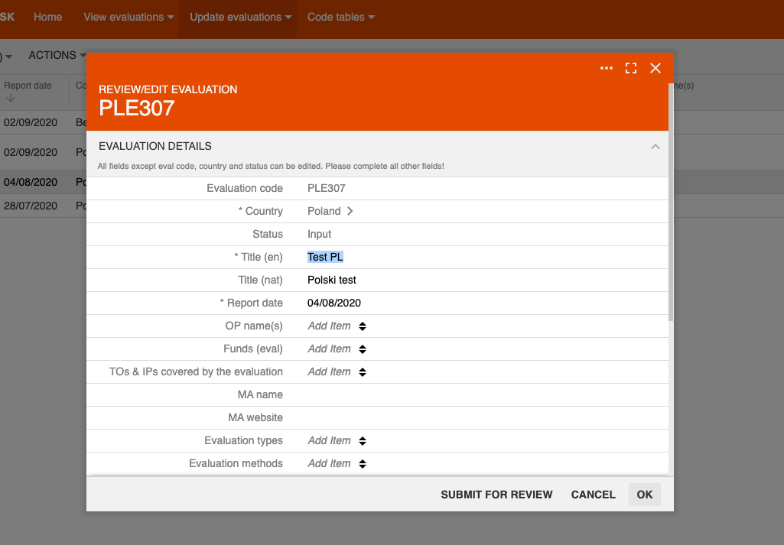

Fill in all the relevant information (as suggested in the template below):

|  |  |
| --- | --- |
| **Fields of the Template** | **Comments** |
| Evaluation code | *Automatically added* |
| Country | *It cannot be changed* |
| Status | Input – *this entry cannot be changed* |
| Title (en) | Title included in the 1st step can be changed. Please note that it does not need to be a literal translation of the title in national language. It should be concise. |
| Title (nat) | Title included in the 1st step can be changed. |
| Report date | Date included in the 1st step can be changed. |
| OP name(s) | Add all relevant OPs  All OPs relating to 2007-13 and 2014-20 are listed and you can select from the list. If the evaluation covers all OPs of both periods, select the option ‘Select all’.  If the evaluation is part of the Partnership Agreement or is about a horizontal topic, please select all OPs concerned.  Notes:   1. Information on CCI number, programming period and OP Fund(s) are automatically determined once the OP Name(s) is indicated. These fields are therefore not included in the input template (but the information will appear in the database). 2. A list of all OPs and CCI codes is included among the Code tables. 3. Since the list of OPs related to the 2021-2127 period is not yet available indicate the OP(s) related to the current period for ex-ante evaluations or preparatory studies related to the 2021-2027 period |
| Funds (eval) | Select the Fund(s) covered by the **evaluation.** |
| TOs & IPs covered by the evaluation | When the evaluation refers to specific IP(s), please indicate them rather than the more general TO number.  Use the label “All TO/IPs” for evaluations that are concerned with all TOs/IPs of an OP which is typically the case for: (1) Evaluations using macro-modelling approaches to estimate overall effects from the OP, (2) Process/implementation-oriented and/or monitoring/process-oriented evaluations which cover all TO/IPs of the OP. This option cannot be selected for evaluations concerned with multiple OPs in which case you need to select them manually.  Please disregard the option ‘Select All’ (which is automatically generated by the software).  Note: A list of TOs /IPs is included in the Code tables. |
| MA name | Enter the relevant information |
| MA website | Enter the relevant information |
| Evaluation types | Select the type of the evaluation (as claimed in the evaluation) which are:   * Impact/Result-orientated (**I**) * Process/Implementation-oriented (**P**) * Monitoring/Progress-oriented (**M**) * Summary of evaluations/meta-analysis (S), aimed at summarising findings of a number of previous evaluations * Other reports (**R**), Studies of various kinds which are not evaluations as such, but which, for example, simply document the reprogramming of an OP or analyse socio-economic developments or financial, labour and other market conditions as preparatory studies for 2021-2027 programmes, which are not proper ex ante evaluations, in the sense of assessing specific policy options or their delivery (*NEW CATEGORY*).   A list of types is included in the Code tables. |
| Evaluation methods | Select the methods used for the evaluation (such as set out in the report)  Note: in addition to Theory based evaluations (TBIE), Counterfactual Impact evaluations (CIE), Cost benefit analysis (CBA), Other quantitative methods (QUAN) and Other qualitative methods (QUAL), a new method has been added: Macro modelling (MOD).  A list of methods is included in the Code tables. |
| Types of data used | **NEW**  Select the kinds of data which are used for the evaluation (Statistical Office data (SO), Monitoring data (MON), Administrative data (ADMIN), Data collected by the evaluator (EVAL), Other secondary data (OTH)).  A list of data is included in the Code tables. |
| Link (original) | This link should lead **directly to the pdf** file of the evaluation. Please make sure that the link works. |
| Publication date | Indicate the publication date (only month and year will be shown)  Enter the date indicated in the evaluation report. If not available, use the date of publication on the website. |
| Language | Select the language of the evaluation |
| Authors | Indicate the names of authors where available and the organisation |
| Authors contact | Include the name of organisation, address, website and email, if available |
| Source of information | Indicate ‘National expert’ |
| Link with previous evaluation(s) | If the evaluation relates to a previous evaluation already identified (e.g. they refer to the same OP/project(s), one being the interim report and the other the final one), select here the code of the previous evaluation concerned. |

Once all fields are completed, there are three options. Click:

* **Ok** to save the evaluation in the List of ‘New evaluations’ if you would like to be able to modify any information
* **Submit for review** to send the evaluation to the Helpdesk Team. Please note that after you click on Submit for review, you have to press **Ok** on the following window. Without pressing ‘Ok’ the evaluation will not be submitted.
* **Cancel** to cancel all information included in the template

The evaluation included will be stored in the List of New evaluations until you submit it for review. Before doing this, please check carefully that the information is correct and complete. You can correct/add information in the evaluation Template and save it as many times as you need as long as it is not submitted for review.

|  |
| --- |
| **Important**:  Pay particular attention to:   * select the ‘right’ country when you include a new evaluation * include an evaluation only when you are sure it should be reported in the Database (e.g. it is not a study rather than an evaluation, it is not an annual implementation report or it is not already included). * Those which are preparatory studies and not proper ex-ante evaluations 2021-2027 should be classified as ‘Other reports’.   If you have any doubt about a document whether it should be reported or not, please contact us via email. |

Please submit before the 25 of each month. Send us a confirmation via e-mail to Francesca Liberati ([fl@applica.be](mailto:fl@applica.be)) and Lydia Greunz ([lg@applica.be](mailto:lg@applica.be)) once you have done so.

If no evaluation is identified during the month, please send an email confirming this by the same date (i.e. by the 25 of the month) for our records.

Please send the evaluation reports themselves by uploading them on Dropbox using the link which has been circulated via email (you can upload the files even without a Dropbox account) or alternatively upload them directly on a Dropbox folder shared with you. Please name the file(s) with the evaluation code assigned to the evaluation (send also the evaluation summary (also in EN) and annexes if available).